Automobile Ontology

Matthew Krieger

**Objective**:

The objective of Automobile Ontology is to enable search regarding automobile of any and every category. The search includes multimedia objects for attractive interface and implement easy to understand fashion. The Project focuses mainly on keyword based search and also sparql query based search to retrieve desired results.

**Data Set Description:**

Data Set comprises mainly of images and videos annotated in order to enable keyword based searching and easy access upon sparql queries. We are using 75 images, 42 videos for our project divided into categories such as Sports Car, Metro, Mono Rail, Passenger Plane, Fighter Plane and many more.

**Ontology Statistics:**

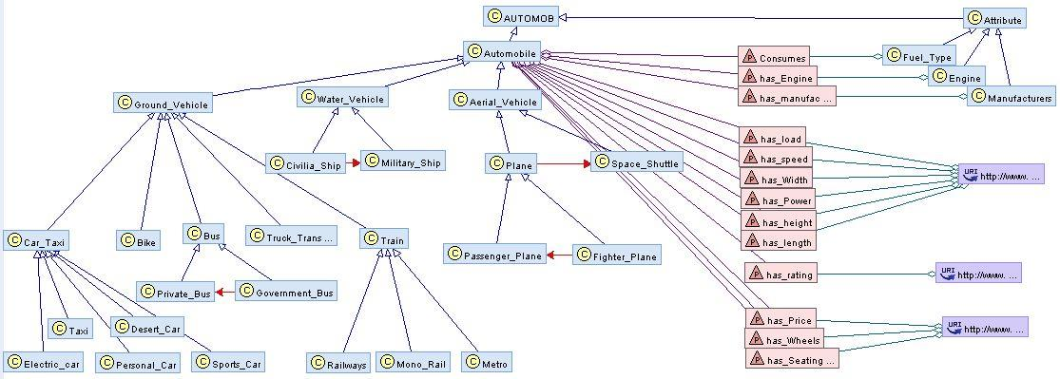Ontology is designed in easy to use manner comprising of base class (Automob) having child Attributes and Automobile which further have subclasses as described by the following graph.

Ontology is designed in easy to use manner comprising of base class (Automob) having child Attributes and Automobile which further have subclasses as described by the following graph.

**Demo Goals:**

1. Help audience understand how to get flexible search related to their queries for the type of automobile they want.
2. To describe working and implementation of the project.
3. To give detailed description for every kind of automobile user searches for.